In convolutional neural networks we are using so called filters. This is a matrix. We take a part of an image (which is also a matrix) and multiply it by a filter. Then we take another part of an image and again multiply it by the same filter. It looks like this:
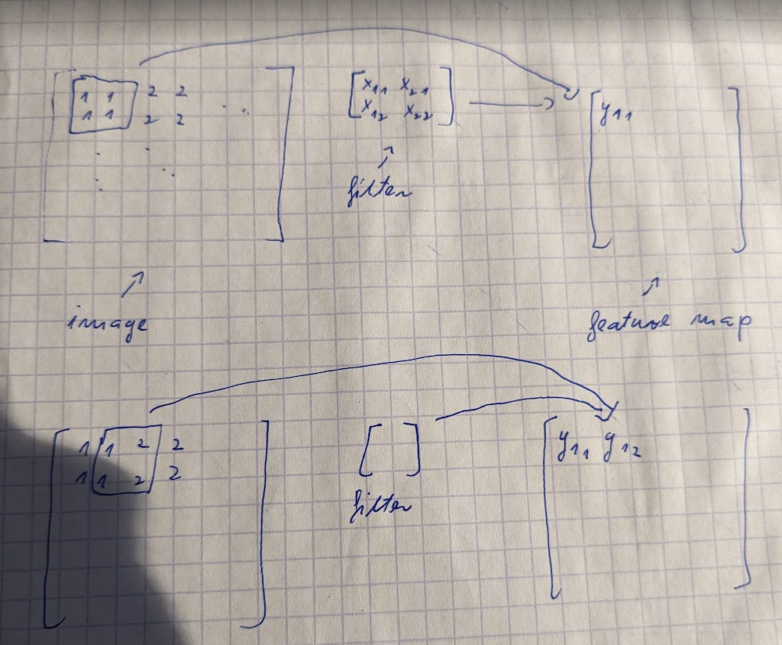

We are creating so called the feature map by multiplying different parts of an image by a filter.

Filter consists of trainable parameters. We are using multiple, different filters in order to create different feature maps.

We are applying pooling to feature maps. It works such that we are taking a part of a feature map and select from it just 1 number. It can be for example maximum number (max pooling) or average value (mean pooling). In this way we are reducing size of a feature map:
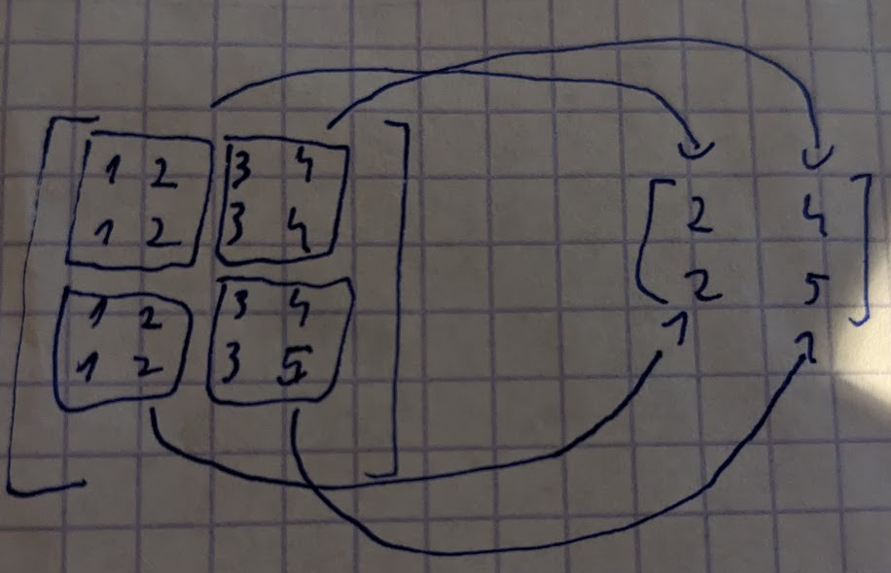

We are doing this in order to extract the most important information.

